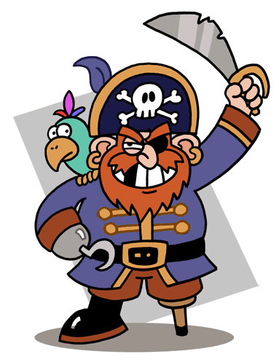
Pirate Alliteration

Can you think of alliterative sentences for each of the following Pirates?

Here’s an example for all you Landlubbers:
Bluebeard
Big, bad, brave, Bluebeard burns baked beans beside barrels of bubblegum.

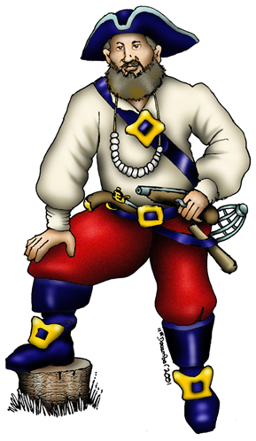
Now it’s your turn me Hearties!
Cut-throat Clive
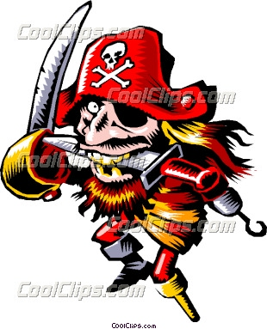
Ruthless Ruth the Redhead

Peg-leg Pete
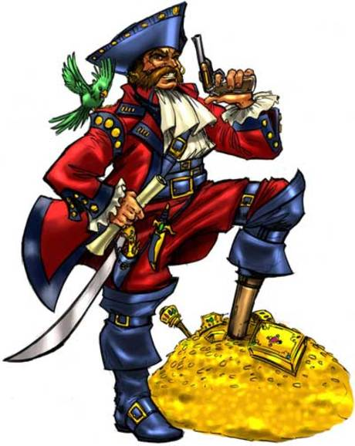
Savage Sue

Jolly Jake Jack-knife

Fearless Flint the Ferocious

Terrible Tom the Torturer
Shameless Shirley Ship-shape

Menacing Marvin the Miserable

