At the seaside

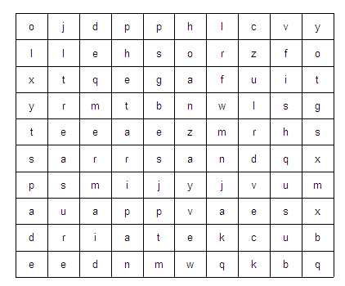

crab | mermaid | sand
sea | bucket | shell
spade | treasure | fish
pirate

