At the seaside

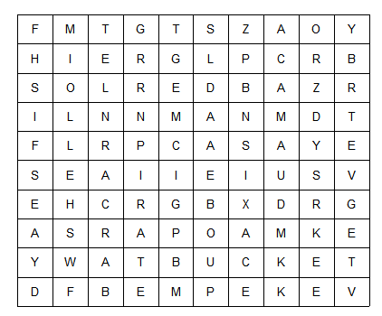

CRAB | SEA | SHELL
MERMAID | BUCKET | SPADE
SAND | TREASURE | PIRATE
FISH

